

*  Read this article.

### Mercosur: A Brief History

The Mercosur trade bloc had its roots in the 1991 Treaty of Asuncion, when the nations of Brazil, Argentina, Uruguay and Paraguay set up a common market to ease tariffs and spur commerce. It counts 225 million consumers and a combined GDP of nearly $1.2 trillion and now includes Chile, Bolivia and Peru as associate members. But the bloc has been plagued by economic woes and internal trade bickering in the past several years.

1991 - The presidents of Brazil, Argentina, Paraguay and Uruguay signed a blueprint accord to create a common market stretching from the Equator to the Antarctic to compete with other world trading blocs. The Southern Common Market treaty, known as Mercosur, would dismantle trade barriers and encourage cross-border investment and joint projects over the next four years.

1994 - The aftermath of Mexico's 1994 peso crisis proved the biggest threat yet to comity in Mercosur. With speculators attacking its economy, Brazil enrages Argentina by unilaterally imposing restrictions on auto imports to defend its own commercial interests. The dispute grew so bitter that one Argentine newspaper provoked a formal diplomatic protest from Brazil's government by publishing a racist editorial cartoon about Brazilians.

1995 January - Argentina, Brazil, Uruguay and Paraguay concluded a four-year phaseout of tariffs. Integration moved inexorably onward throughout the Mercosur countries. Some 300 Brazilian companies established a presence in Argentina. Argentina is now second only to Saudi Arabia as a supplier of oil to Brazil. Paraguay now imports nearly as many Brazilian products as English goods.

1995 December - Bolivia became the first country to associate itself with the Mercosur under a so-called four-plus-one formula.

1996 - Chile signed a free-trade accord with Mercosur.

1997 - Mercosur leaders begann to consider a regional common currency, but the idea was a long way from becoming reality. Six years after their formation, intrabloc commerce grew more than fourfold to $34.22 billion in 1996 from $8.37 billion in 1990.

1998 - Mercosur was now the world's third-largest economic bloc after the North American Free Trade Agreement and the European Union.

1999 January - Trade friction began between Brazil and Argentina when Brazil devalued its currency, making its goods about 35% cheaper in Argentina where the peso was pegged to the U.S. dollar. Beginning then, despite efforts to gloss over difference between the bloc's two largest players, tensions flare up from time to time.

1999 June - The European Union opened negotiations with Mercosur on a free trade agreement.

2000 April - Members agreed to set common debt, deficit and inflation goals as of March 2001 in order to have the region's economies marched at the same pace.

2000 September - Mexico opened free-trade talks with Mercosur.

2000 December - Chile moved to negotiate its own free-trade agreement with the U.S., as Mercosur struggled to stay on track amid Argentina's economic crisis.

2001 - Brazil suspended bilateral trade talks with Argentina until Buenos Aires agreed to back off a move to exempt a wide batch of goods for countries outside Mercosur from import tariffs.

2002 February - Two months of social, political and economic turmoil in Argentina caused a revolving door of five presidents, forces the country to default on its $141 billion public debt and devalued its currency, the peso, by nearly 50%. The financial troubles in Argentina partially affected other Mercosur nations. Uruguay's banking system was suffering, and exports from across the region to Argentina - South America's second-largest economy - fell sharply because of the crisis.

2002 December - Mercosur leaders approved a treaty making it easier for residents of each member country to move freely and work across the region.

2003 December - Mercosur and The Andean Community, South America's two largest trade groups, stroke a free trade accord, moving to link up 10 regional economies amid ongoing talks led by the U.S. on a Free Trade Area of the Americas agreement.

2004 July - Venezuela joined the growing list of Mercosur "associate" states.

Argentina imposed a 21% tariff on TV sets imported from Brazil's duty-free zone of Manaus. Argentina also took steps against Brazilian imports of such goods as refrigerators and stoves -- moved labeled by one Brazilian trade group as overly protectionist.

2004 October - Mercosur came up short in negotiations to reach new trade dealt with the European Union, and with the U.S. for a 34-nation free trade zone that would span the Americas. The failed talks came at an inopportune time for Mercosur, just as claimed by experts that Mercosur doesn't work and had to be fixed or disbanded were increasing. Farm goods, which remained economically vital for Mercosur members, were central to the impasse with the EU. Traditional farming countries such as France, Spain and Ireland defy EU proposals to accept more Latin beef, poultry and sugar.



* Answer the following questions in Spanish.

1. What is the Mercosur?

El mercosur es mercado común del sur

Southern Common Market treaty

1. When was it created?

Fue creado en 1991

1. Did the European Union participate? Why? / Why not?
2. What can you say about Venezuela?
3. Use this timeline above to find out more about Mercosur history.

#### MC900404011[1]GRAMMAR IN USE

* Distribute some of the verbs from the text in the box

|  |  |
| --- | --- |
| **Regular verbs** | **Irregular verbs** |
| joined | had |
|  |  |
|  |  |
|  |  |
|  |  |
|  |  |
|  |  |
|  |  |
|  |  |
|  |  |

* Analyse the selected verbs above.

| **Tense** | **Conjugated form** | **Person** | **Use** |
| --- | --- | --- | --- |
| Simple past | was | 3ª del singular | Situación permanente |
|  |  |  |  |
|  |  |  |  |
|  |  |  |  |
|  |  |  |  |
|  |  |  |  |
|  |  |  |  |
|  |  |  |  |
|  |  |  |  |
|  |  |  |  |

* Are these gerunds nouns, adjectives or verbs? Find more examples in the text.

|  |  |
| --- | --- |
| attacking |  |
| banking |  |
| revolving |  |
|  |  |
|  |  |
|  |  |

* Find adverbs in the text and translate them.

| **Adverb** | **Translation** |
| --- | --- |
| unilaterally | *unilateralmente* |
|  |  |
|  |  |
|  |  |
|  |  |
|  |  |

* Find an example of past continuous, explain the function in the text and translate it.

|  |
| --- |
| Sentence: |
| Use: |
| Translation: |

#### MC900404011[1]ADVERBS

|  |  |  |
| --- | --- | --- |
| **De modo** | *How?* | Better, fast, slowly, carefully |
| **De lugar** | *Where?* | There, under, away |
| **De tiempo** | *When?* | Early, late, soon, tomorrow |
| **De duración** | *How long?* | Always, once a week |
| **De frecuencia** |  | Always, never, often |
| **De orden** | *In what order?* | Firstly, finally |
| **De grado** | *To what degree?* | Completely |
| **De certeza** | *How sure?* | Indeed, of course |

##### Los adverbios de modo

Los adverbios de modo nos dicen cómo se realiza la acción. Los adverbios pueden modificar verbos, adjetivos y otros adverbios.

Los adjetivos nos dicen algo de una persona o una cosa.

|  |  |
| --- | --- |
| **Adjective** | **Adverb** |
| Mandy is a **careful** girl. (1)  Mandy is very **careful**. | Mandy drives **carefully**. (2) |

(1) *Mandy is a* ***careful*** *driver.* La oración se refiere a Mandy, por eso usamos un adjetivo (adjective).

(2) *Mandy drives* ***carefully****.* Esta oración se refiere a cómo Mandy realiza la acción, por lo tanto usamos el adverbio (adverb).

**Form**

**Adjective + -LY**

|  |  |
| --- | --- |
| **Adjective** | **Adverb** |
| dangerous | dangerously |
| careful | carefully |
| nice | nicely |
| easy | easily |
| horrible | horribly |
| electronic | electronically |

|  |  |
| --- | --- |
| **Irregular forms** | |
| good | well |
| fast | fast |
| hard | hard |

**Not all words ending in -ly are adverbs.**

*adjectives ending in -ly:* friendly, silly, lonely, ugly

*nouns, ending in -ly:* ally, bully, Italy, melancholy

*verbs, ending in -ly:* apply, rely, supply

**Adjetivos y adverbios que tienen la misma forma.**

| **Adjective** | **Adverb** |
| --- | --- |
| close | close |
| daily | daily |
| early | early |
| fair | fair |
| far | far |
| fast | fast |
| free | free |
| hard | hard |
| high | high |
| late | late |
| lively | lively |
| long | long |
| lovely | lovely |
| low | low |
| right | right |
| wide | wide |
| wrong | wrong |

Es muy importante fijarse en la función de la palabra para poder identificar si es un adjetivo o adverbio.

|  |  |  |
| --- | --- | --- |
| The train goes fast | 🡺 | *Fast* es adverbio porque explica cómo va el tren. |
| It is a fast train . | 🡺 | *Fast* está modificando a *train*. Es adjetivo. |

* Recognize adjectives and adverbs.

|  |  |
| --- | --- |
|  | **Adjective or adverb?** |
| She turned quickly. It was a quick turn. |  |
| The president spoke well today. |  |
| This newspaper is published daily. |  |
| I will catch the train early. |  |
| Unfortunately, the sky quickly grew dark. |  |
| The cat ran incredibly quickly. |  |
| Why did she resign so mysteriously? |  |

#### MC900404011[1]SIMPLE PAST

Usamos el Pasado Simple para expresar que una acción comenzó y termino en un tiempo específico en el pasado.

simplepast

|  |  |  |  |
| --- | --- | --- | --- |
| ***E.g.*** | *I saw a movie yesterday.* | Ayer vi una película. | **Ej.** |
| *I didn't see a play yesterday.* | No vi una obra de teatro ayer. |
| *Last year, I traveled to Japan.* | El año pasado viaje a Japón. |

Se utiliza en una serie de acciones completas que sucedieron una detrás de la otra.

simplepastseries - copia

|  |  |  |  |
| --- | --- | --- | --- |
| ***E.g*** | *I finished work, walked to the beach, and found a nice place to swim.* | Terminé de trabajar, fui a la playa y encontré un lindo lugar para nadar. | **Ej.** |

Se utiliza en hábitos que culminaron en el pasado.

simplepastseries

|  |  |  |  |
| --- | --- | --- | --- |
| ***E.g.*** | *I studied French when I was a child.* | Estudiaba francés cuando era un niño. | **Ej.** |
| *He played the violin.* | Tocaba el violín. |

Los verbos en pasado pueden ser regulares o irregulars.

|  |  |  |
| --- | --- | --- |
|  | **Regulares** | **Irregulares** |
|  | Los verbos regulares llevan **–ed**. | Los verbos irregulares cambian totalmente por lo cual se debe aprender cada uno de ellos. |
| ***E.g.*** | visit – visit**ed**  move – mov**ed** | go – **went**  write – **wrote** |

##### Pasado simple en negativo

En Simple Past utilizaremos el auxiliar to do, cuyo pasado negativo did not, se contrae en didn't. Es el verbo auxiliar el que indica que es pasado, ya que el verbo principal está siempre en infinitivo. La forma did not / didn't es la misma para todas las personas.

|  |  |  |  |
| --- | --- | --- | --- |
| ***E.g.*** | *I didn't (did not) smoke.* | Yo no fumo. | **Ej.** |
| *She didn't (did not) smoke.* | Ella no fumó. |
| *I didn't like the film.* | No me gustó la película. |
| *You didn't phone me.* | No me telefoneaste. |

##### Verbo “ to be “ en pasado

-El verbo "To be" en pasado se traduce normalmente como: *I was= Yo era/ Yo estaba*

Aunque conserva todos los usos que vimos en el presente.

La irregularidad está en la primera persona "I was"y la tercera del singular "he was, she was, it was”.

El afirmativo se forma así:

|  |  |
| --- | --- |
| pasado3 | pasado1 |

El negativo se forma así:

|  |  |
| --- | --- |
| pasado8 | pasado5 |

El interrogativos se forma así:

|  |  |
| --- | --- |
| pasado9 | pasado10 |

#### MC900404011[1]APPLICATIONS “-ING”

La terminación –ing se puede observar en un sustantivo, un adjetivo o un verbo. Es fundamental que distingamos qué función tiene cada palabra para poder determinar si estamos en presencia de un sustantivo, adjetivo o verbo.

Veamos algunos ejemplos.

##### Adjetivos

|  |  |  |
| --- | --- | --- |
| http://cdn01.ib.infobae.com/adjuntos/162/imagenes/012/033/0012033671.jpg | ***E.g.*** | *This is an amazing picture.* |
| **Ej.** | Esta foto es sorprendente |
| La palabra “amazing” es adjetivo, debido a que está modificando a un sustantivo, en este caso: “picture”. | |

##### Sustantivos

|  |  |  |
| --- | --- | --- |
| http://trucoslondres.com/wp-content/uploads/2015/09/large-63.jpg | ***E.g.*** | *Reading is wonderful.* |
| **Ej.** | *Leer es maravilloso.* |
| La palabra “Reading” es un sustantivo ya que es el núcleo del sujeto. Sólo los sustantivos pueden ser núcleos del sujeto. | |

|  |  |  |
| --- | --- | --- |
| http://www.estudiarcomputacion.gob.ar/media/cms_page_media/3/banner-becas.jpg | ***E.g.*** | *I like computing.* |
| **Ej.** | Me gusta la computación. |
| La palabra “computing” se refiere a una actividad y es el objeto directo de la oración. | |

##### Verbo

|  |  |  |
| --- | --- | --- |
| https://i.ytimg.com/vi/B67WGXNdjBM/maxresdefault.jpg | ***E.g.*** | *He is working hard.* |
| **Ej.** | El está trabajando duro. |
| En este ejemplo vemos claramente que “ working” está utilizado como un verbo , formando parte del Presente Continuo. Esto quiere decir  **verbo “to be” + verbo –ing.** | |

* Underline the words finished in -ing and recognize.

|  | **Noun, adjective or verb?** |
| --- | --- |
| Driving is getting dangerous. |  |
| I love swimming in summer. |  |
| Running is a good exercise. |  |
| I am trying to keep on working. |  |
| This class is tyring. |  |
| I watched an amazing film yesterday. |  |

#### MC900404011[1]PAST CONTINUOUS

Para formar el **pasado continuo** se utiliza el verbo auxiliar “to be” y el gerundio (infinitivo + “-ing”) del verbo. El verbo auxiliar “to be” está en el pasado simple, pero ten en cuenta que “to be” es un verbo irregular.

|  |  |  |
| --- | --- | --- |
| **Sujeto** | **Auxiliar (to be)** | **Gerundio** |
| I, he, she, it | was | talking, eating, learning, doing, going… |
| you, we, they | were | talking, eating, learning, doing, going… |

##### Affirmative Sentences

**Sujeto + verbo auxiliar (to be) + gerundio.**

|  |  |  |  |
| --- | --- | --- | --- |
| ***E.g.*** | *I was talking.* | Estaba hablando. | **Ej.** |
| *He was eating.* | Estaba comiendo. |
| *They were learning.* | Estaban aprendiendo. |

##### 

##### Negative Sentences

**Sujeto + verbo auxiliar (to be) + “not” + gerundio.**

|  |  |  |  |
| --- | --- | --- | --- |
| ***E.g.*** | *I was not [wasn’t] talking.* | No estaba hablando. | **Ej.** |
| *He was not [wasn’t] eating.* | No estaba comiendo. |
| *They were not [weren’t] learning.* | No estaban aprendiendo. |

##### Interrogative Sentences

**¿Verbo auxiliar (to be) + sujeto + gerundio?**

|  |  |  |  |
| --- | --- | --- | --- |
| ***E.g.*** | *Were you talking?* | ¿Estabas hablando? | **Ej.** |
| *Was he eating?* | ¿Estaba comiendo? |
| *Were they learning?* | ¿Estaban aprendiendo? |

##### Uses

**El pasado continuo lo utilizamos para una acción larga que ya en el pasado fue interrumpida.** La acción que se interrumpe está en pasado continuo y la acción que provoca la interrupción está en pasado simple. “**When**” y “**while**” señalan el uso del pasado simple y continuo. En general, usamos el pasado simple directamente después de “**when**” y el pasado continuo después de “**while**”.

|  |  |  |  |
| --- | --- | --- | --- |
| ***E.g.*** | *Jose called while I was watching the news.* | Jose llamó mientras estaba mirando las noticias. | **Ej.** |
| *He was walking to work when he fell.* | Estaba caminando hacia su trabajo cuando se cayó. |
| *Was it raining when you left?* | ¿Estaba lloviendo cuando te fuiste? |

**Se usa el pasado continuo para hablar sobre acciones en un tiempo específico en el pasado.**

|  |  |  |  |
| --- | --- | --- | --- |
| ***E.g.*** | *Paula wasn’t living in Spain in 2005.* | Paula no estaba viviendo en España en el 2005. | **Ej.** |
| *We were still working at 10 o’clock last night.* | Todavía estábamos trabajando a las 10 de la noche. |

**Se usa el pasado continuo para dos acciones que estaban ocurriendo al mismo tiempo en el pasado.**

|  |  |  |  |
| --- | --- | --- | --- |
| ***E.g.*** | *My son was reading while I was cooking.* | Mi hijo estaba leyendo mientras que yo estaba cocinando. | **Ej.** |
| *They were talking very loudly while we were trying to watch the movie.* | Estaban hablando muy alto mientras nosotros estábamos intentando mirar la película. |



# Lesson 3

## New Trends in Architecture

* 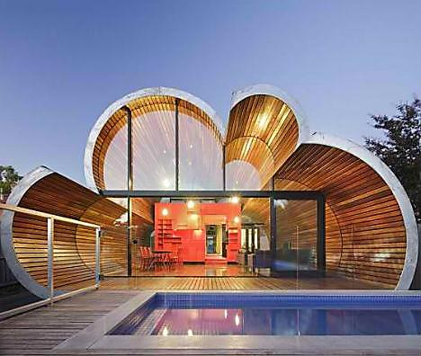Answer the following questions in Spanish.

1. Do you live in a house or in an apartment?

Yo vivo en una casa

1. What are the advantages and disadvantages of living in a house in the suburbs?
2. What are the advantages and disadvantages of living in an apartment in the city centre?
3. How do you imagine houses will be in the year 2050?
4. What do you think organic architecture is?

*  Read this article about “Organic Architecture”*.* Think of a sentence in Spanish to summarize each paragraph.

### Organic Architecture

**1.**

Organic architecture -that is, natural architecture- can vary in concept and form, but it is always faithful to natural principles. The architect dedicated to the promulgation of organic architecture rejects all rules imposed by individual preference or mere aesthetics in order to remain true of the nature of the site, the materials, the purpose of the structure, and the people using it.

**2.**

Moreover, form does not follow function; form and function are inseparably two aspects of the same phenomenon. In other words, nature’s forms must inspire the building, and it should maximize people’s contact with and utilization of the outdoors. Furthermore, the rule of functionalism is respected: that is, the principle of excluding everything that serves no practical purpose.

**3.**

Natural principles are principles of design, not style, expressed by means and modes of construction that reflect unity, balance, proportion, rhythm, and scale. Like a sculptor, the organic architect views the site and materials as an innate form that develops organically from within.

**4.**

Truth in architecture results in a natural, spontaneous structure in total harmony with the setting. For all these reasons, these structures find their geometric shapes in the contours of the land and their colors in the surrounding palette of nature.

**5.**

From the outside, an organic structure is a part of nature. To put it another way, it may not be easy, or maybe not even possible, for the human eye to separate the artificial structure from the natural terrain. Natural light, air and view permeate the whole structure, providing a sense of communication with the outdoors.

**6.**

From the inside, living spaces open into one another, allowing the functional spaces to flow together. Additionally, the interiors are sparse. Organic architecture incorporates built-in architectural features such as benches and storage areas to take the place of furniture.

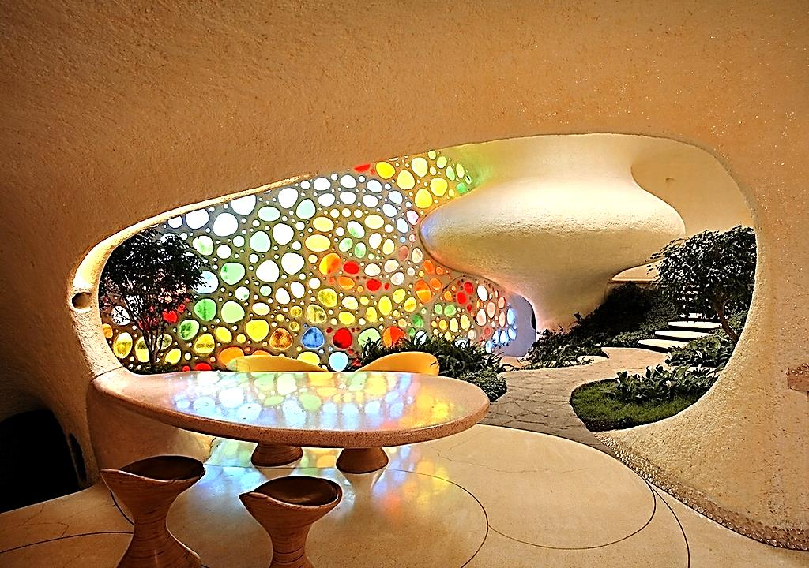

*  What does the text say about the following concepts?

|  |  |
| --- | --- |
| **Individual Preference or Mere Aesthetics** |  |
| **Form and Function** |  |
| **Harmony** |  |
| **The Utilization of the Outdoors** |  |
| **Functionalism** |  |
| **Principles of Design** |  |
| **Truth** |  |
| **Interiors** |  |

#### “ING” WORDSMC900404011[1]

* Now look at the following examples from the text and decide whether the words in bold are verbs, adjectives, nouns or adverbs.

|  |  |
| --- | --- |
| **Examples from the text** | **Function of the ING word** |
| …the principle of **excluding** everything that serves no practical purpose. |  |
| Truth in architecture results in a natural, spontaneous structure in total harmony with the **setting**. |  |
| For the most part, these structures find their geometric shapes in the contours of the land and their colors in the **surrounding** palette of nature. |  |
| From the inside, **living** spaces open into one another, allowing the functional spaces to flow together. |  |
| From the inside, living spaces open into one another, **allowing** the functional spaces to flow together. |  |

#### http://www.literautas.com/es/blog/wp-content/uploads/eye-magnifying-glass-book.gifRemember!

Estas palabras tienen distintas funciones dependiendo de su ubicación dentro de la oración:

|  |  |  |
| --- | --- | --- |
| **Función sustantivo:** Cuando la palabra ocupa lugar de sujeto, objeto directo o complemento de preposición. | **E.g.** | *Sujeto:* ***Swimming*** *is healthy for you.*  *Objeto directo: I like* ***swimming****.*  *Complemento de preposición: I am interested in* ***swimming****.* |
| **Función adjetivo:** Cuando la palabra con *ing* se encuentra adelante de un sustantivo o detrás calificando al mismo. | **E.g.** | *The boy* ***sitting*** *next to me is a very good person.*  *The* ***managing*** *director is a good person.* |
| **Función verbo:** Cuando está precedida del verbo to be (am, is, are, was, were…). | **E.g.** | *I am* ***sitting*** *here.* |
| **Función adverbio:** Cuando responde a *cómo* se realizó tal o cual acción. | **E.g** | ***Sitting*** *next to me, the boy is very quiet.* |

#### CONNECTORS MC900404011[1]

* Now look at the following sentences from the text. Underline the connectors and state their functions.

|  |  |
| --- | --- |
| **Example from the text** | **Function** |
| Organic architecture -that is, natural architecture- can vary in concept and form, but it is always faithful to natural principles. |  |
| The architect dedicated to the promulgation of organic architecture rejects all rules imposed by individual preference or mere aesthetics in order to remain true of the nature of the site… |  |
| …true of the nature of the site, the materials, the purpose of the structure, and the people who will ultimately use it. |  |
| Moreover, form does not follow function; form and function are inseparably two aspects of the same phenomenon. |  |
| In other words, a building should be inspired by nature’s forms and constructed with materials that retain and respect the natural characteristics of the setting to create harmony between the structure and its natural environment. |  |
| Furthermore, the rule of functionalism is respected: that is, the principle of excluding everything that serves no practical purpose. |  |
| For all these reasons, these structures find their geometric shapes in the contours of the land and their colors in the surrounding palette of nature. |  |
| To put it another way, it may not be easy, or maybe not even possible, for the human eye to separate the artificial structure from the natural terrain. |  |
| Additionally, the interiors are sparse. |  |
| Organic architecture incorporates built-in architectural features such as benches and storage areas to take the place of furniture. |  |

#### http://www.literautas.com/es/blog/wp-content/uploads/eye-magnifying-glass-book.gifRemember!

Los conectores (en inglés denominados: “connectors” o “linking words”) son aquellas palabras empleadas a fin de mostrar la relación entre las ideas de un texto. Se pueden emplear por ejemplo para unir dos o más cláusulas u oraciones. Indican *adición*, *condición*, *contraste*, *propósito*, entre otros. En otras palabras, nos permiten organizar las ideas en el texto en cuanto a la cohesión gramatical. Son herramientas empleadas por los autores con el objetivo de conectar las ideas para que el lector pueda seguirlas en forma clara. En el proceso de lectura, nos permiten anticipar el significado de una frase u oración.

##### bd05090_Algunos conectores

|  |  |  |  |
| --- | --- | --- | --- |
| ***E.g.*** | *Mary plays not only the piano* ***but*** *also the guitar.* | Mary no sólo toca el piano **sino** también la guitarra. | **Ej.** |
| *I don't know her phone number,* ***therefore*** *I can't call her.* | No sé su número de teléfono, **por lo tanto**, no puedo llamarla. |
| *It was very rainy;* ***nevertheless****, we went to the beach.* | Estaba muy lluvioso; **sin embargo**, fuimos a la playa. |
| *Jack is a solitary boy.* ***On the contrary****, Peter has many friends.* | Jack es un niño solitario. **Por el contrario**, Peter tiene muchos amigos. |
| ***Although*** *John is not very slim, he is a very fast runner.* | **Aunque** John no es muy delgado, es un corredor rápido. |

* For more info on connectors, visit:

<http://www.bossmeyer.gidw-online.de/Textarbeit202/List20of20Connectors.htm>

<http://mbonillo.xavierre.com/gramatica/markers.html>

*  Read this biography.

### César Pelli

Cesar Pelli was born in Argentina in 1926. He earned his diploma in Architecture from the University of Tucuman. Then he moved to the USA. When he was studying at the University of Illinois, he married Diana Balmori, a renowned landscape and urban designer.

He first worked in the offices of Eero Saarinen serving as Project Designer for several buildings, including the TWA Terminal at JFK Airport in New York and Morse and Stiles Colleges at Yale University.

In 1977, when he was working as Dean of the Yale University School of Architecture, Mr. Pelli founded Cesar Pelli & Associates. He resigned his post as Dean in 1984, but continued to lecture on architecture. Since the firm’s establishment, Mr. Pelli personally originated and directed the design of each of its projects.

Mr. Pelli avoids formalistic preconceptions in his designs. He believes that buildings must be responsible citizens and that the aesthetic qualities of a building must grow from the specific characteristics of each project like its location, its construction technology, and its purpose.

He received twelve Honorary Degrees, 200 awards for design excellence and is a Fellow of the American Institute of Architects, a Member of the American Academy of Arts and Letters, the National Academy of Design, the International Academy of Architecture, and of l’Academie d’Architecture de France.

In 1995, the American Institute of Architects awarded Mr. Pelli the Gold Medal, in recognition of a lifetime of distinguished achievement in architecture. In 2004, they gave him an award for the design of The Petronas Towers in Kuala Lumpur, Malaysia.

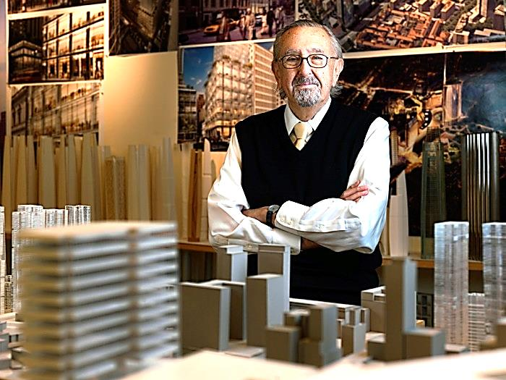

* Complete the table with information related to the text in Spanish.

|  |  |
| --- | --- |
| **His personal life** |  |
| **His first jobs** |  |
| **His academic life** |  |
| **His conceptions about architecture** |  |
| **Awards** |  |

#### PAST CONTINUOUSMC900404011[1]

* Recognize two examples of Past Continuous from the text and state their function.

|  |  |
| --- | --- |
| **Examps from the text** | **Function** |
|  |  |
|  |  |

#### http://www.literautas.com/es/blog/wp-content/uploads/eye-magnifying-glass-book.gifRemember!

Este es un tiempo que empleamos para indicar que estábamos en el medio de una actividad en un momento en particular en el pasado.

pastcontinuous

|  |  |  |  |
| --- | --- | --- | --- |
| ***E.g.*** | *I* ***was******singing*** *at the party at 10 pm.*  *I* ***was******not******singing*** *at the party at 10 pm.*  ***Was*** *I* ***singing*** *at the party at 10 pm?* | *She* ***was******playing*** *the piano.*  *She* ***was******not******playing*** *the piano.*  ***Was*** *she* ***playing*** *the piano?* | *They* ***were reading*** *a book.*  *They* ***were not reading*** *a book.*  ***Were*** *they* ***reading*** *a book?* |

**Funciones de este tiempo:**

1) Para expresar una acción en un momento particular en el pasado, la acción comenzó antes de ese momento y no ha finalizado en ese momento.

*Josh* ***was playing*** *tennis at the club yesterday morning.*

2) Para expresar interrupciones de acciones en pasado. *(usando when + pasado simple)*

*Mary and Josh* ***were cooking*** *dinner for their children when the lights went off.*

3) Para expresar simultaneidad o acciones paralelas. *(usando while + pasado continuo)*

*I* ***was studying*** *while he* ***was making*** *dinner.*

4) Para expresar irritación cuando la oración contiene el adverbio de frecuencia *always*.

*She* ***was*** *always* ***coming*** *to class late.*

#### MC900404011[1]GRAMMAR IN USE

* Underline as many connectors as you can in the text
* Now look at the following examples from the text and decide whether the words in bold are verbs, adjectives, nouns or adverbs.

| **Examples from the text** | **Function of the ING word** |
| --- | --- |
| When he was **studying** at the University of Illinois, he married Diana Balmori, a renowned landscape and urban designer. |  |
| He first worked in the offices of Eero Saarinen **serving** as Project Designer for several buildings… |  |
| He first worked in the offices of Eero Saarinen serving as Project Designer for several **buildings**… |  |
| 1977, when he was **working** as Dean of the Yale University School of Architecture… |  |

